Business Template

E-commerce Marketplace

Contents
Business Description 3
1.1 the Benefits of implementing a database. Project Vision 3
2 Model description 3
2.1 Definitions & Acronyms 3
2.2 Logical Scheme 3
2.3 Objects 3

Business Description

the Benefits of implementing a database. Project Vision
The developed DB for the e-commerce marketplace allows you to keep track of goods, customers and buyers, prices for goods and transactions, etc. for trading. The InventoryLog and PricesHistory tables allow you to keep a retrospective (price history and changes in the quantity of goods after sale).
The database (ECommerce) is relational, meets all ACID requirements. It provides:
- atomicity - each table is responsible for one entity/action;
- data integrity - the data in the database is logically linked: each table has its own PRIMARY KEY, which makes it impossible to duplicate data; there are FOREIGN KEYs, which make it impossible to add non-existent data; use of appropriate, data-specific field types;
- data consistency, i.e. they do not contradict each other; are in 3NF; have a fixed price status (a "history" of prices is stored according to the task);
- data traceability, namely: price history, status and transaction logging.
The model's scalability without redesign is ensured by the modularity of components (e.g., multi-stage delivery can be implemented by adding OrderStatus status types) and by event timestamps.
Technical constraints (shown below), such as NOT NULL, FOREIGN KEY, and logical checks (added when building the physical model) allow you to maintain the integrity and correctness of data input.

Model description

Definitions & Acronyms

The following entities and processes require a clear definition:

- Inventory requires a definition of the type of product: physical, available for sale, etc.;

- Order requires a clear link to the date the order was created;

- Price requires a clear division into catalog price, discount price, sale price;

- Transaction (transaction logs) records a change in the order status.

- The following may be misunderstood in the database:

- quantity (in OrderDetails and Inventory), these are different quantities. In the first case, this is the number of products for purchase, in the second - the number of products in stock;

- amount (in Payments) what this price includes (taxes, shipping, etc.);

- status requires a definition of the type of statuses and their attributes.
Duplicate names, roles and abbreviations, namely:
- clientID and sellerID, which refer to the userID in the Users table. It is also possible that the buyer is also a customer.

Logical Scheme
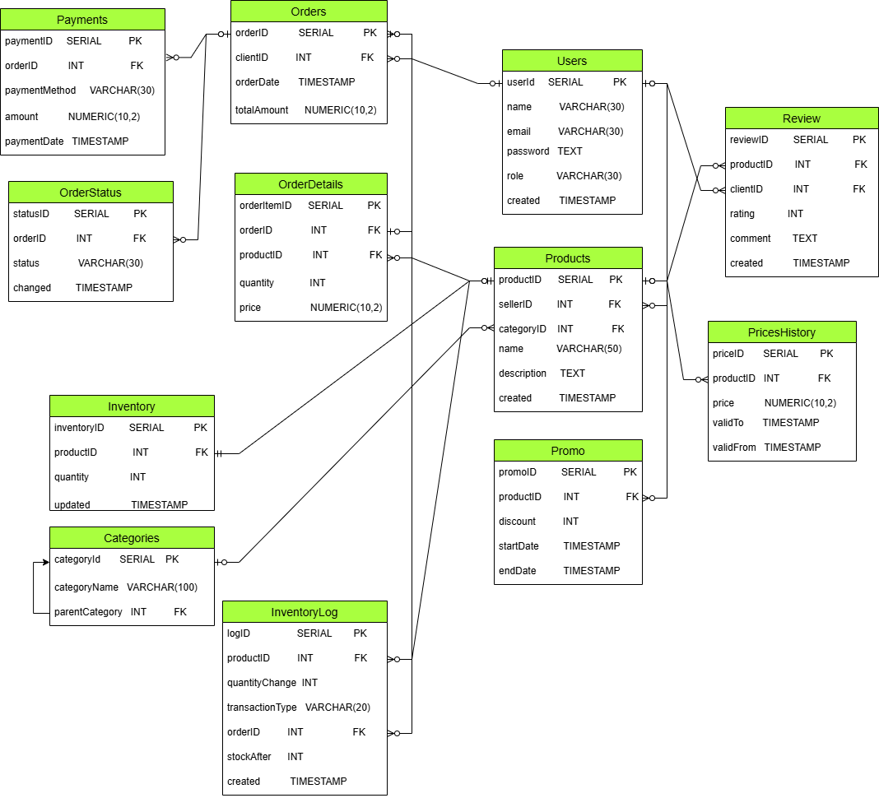

The most difficult to model were the principles of "historicity" of data: prices and products, as well as working with products (movement) and statuses.
When adding new attributes and participants, the model will remain scalable, due to the ACID properties of the table. For example, balance logs, price history, statuses are placed in separate tables. Also, when adding a new participant, for example, a courier, no global processing is required, but simply add a new entity/table Couriers and add courierID (FK) to the Orders or OrderStatus table.
Also, when adding a new role (not only buyers and sellers), it is enough to simply add its value to the role field.
When adding new product attributes, it is enough to simply add them to the Products table.
What will change when expanding the requirements:
- the location of warehouses with products (for example, an all-Ukrainian marketplace) will require adding the Warehouses table and adding a link to Inventory and InventoryLog;
- expanding the promo policy will lead to the appearance of new tables and adding conditions for providing a promotional price;
- the categoryID relationship in the Products table will be replaced by a Many-to-Many relationship if the same product is presented in multiple categories.

Objects
Users is the central registry of all marketplace participants and uses the role field to separate rights (Buyer, Seller, Admin). 3NF is used, since email and password do not depend on anything except userID.
PK is userID (Serial) - a unique numeric user code. Other fields, for example, email is not selected, because the user may want to change email; name - because names may be repeated, etc.
Table Name | Field name | Field Description | Data Type
Users | userID | <user number>, not null, PK | Serial
 | name | <name of user> | Varchar(30)
 | email | <user email/ login> | Varchar(30)
 | password | <user password> | Text
 | role | <user role>: buyer, seller | Varchar(30)
 | created | <date of registration> | Timestamp

Example with data
userID | name | email |  | password | role | created
1 | Semen | 1111@gmail.com | 1111 |  | buyer | 19/10/2025
2 | Lina | 2222@i.ua | 2222 |  | seller | 10/05/2020

Products is a catalog of products offered by sellers. Presented separately, so as not to duplicate the product description in each order. SellerID (FK) indicates who sells; categoryID (FK) - where the product is located (category). The created field is used to track the date of the product's appearance.

Table Name | Field name | Field Description | Data Type
Products | productID | <product number>, not null, PK | Serial
 | sellerID | <user/ seller code>, not null, FK | int
 | categoryID | <category code>, not null, FK | int
 | name | <name of product> | Varchar(50)
 | description | <description of product> | Text
 | created | <date of product registration/ appearance> | Timestamp

Example with data
productID | sellerID | categoryID | name | description | created
1 | 1 | 1 | laptop | HP | 05/05/2026
2 | 2 | 2 | laptop | Dell | 11/03/2026

Categories is a tree-like structure of product classification. The self-referencing parentCategory (recursive FK) relationship allows you to create nested product groups. The PricesHistory field is a time scale of the product cost, which allows you to manage the price history. Created to implement the "must not replace prior information" requirement when adding a record here without changing the price in Products. Manage the price timeline using the validFrom and validTo fields.

Table Name | Field name | Field Description | Data Type
Categories | categoryID | <category number/code>, not null, PK | Serial
 | categoryName | <name of category> | Varchar(100)
 | parentCategory | <previous category code>, not null, FK | int

Example with data
categoryID | categoryName | parentCategory
1 | Electronics | 1
2 | Portative technics | 1
Inventory is the current state of the warehouse, to track the availability of the product. PK/FK: productID is a foreign key that ensures consistency with the catalog. InventoryLog is a log of the movement of the product from the warehouse, manipulations with the product. Located separately, because it explains where the product went. OrderID (FK) links the product write-off to a specific purchase.
Table Name | Field name | Field Description | Data Type
Inventory | invetoryID | <product number>, not null, PK | Serial
 | productID | <product code>, not null, FK | int
 | quantity | <count of product> | int
 | updated | <date of product move> | Timestamp

Example with data
inventoryID | productID | quantity | updated
1 | 1 | 100 | 25/04/2026
2 | 2 | 20 | 14/03/2026

Orders - the intention to buy goods. Represented in 3NF, since there is no list of goods (they are in Details), only general information: who bought, when and for what amount.
Table Name | Field name | Field Description | Data Type
Orders | orderID | <order code>, not null, PK | Serial
 | clientID | <client code>, not null, FK | int
 | orderDate | <date of product order> | Timestamp
 | totalAnount | <final sum> | Numeric(10,2)

Example with data
orderID | clientID | orderDate | totalAnount
1 | 1 | 25/04/2026 | 20000
2 | 2 | 14/03/2026 | 5000

OrderDetails or order details. The price field here is a Snapshot that captures the price at the time of payment so that it does not change in the database retrospectively. FK many-to-one to Orders and to Products.

Table Name | Field name | Field Description | Data Type
OrderDetails | orderItemID | <order item code>, not null, PK | Serial
 | orderID | <order code>, not null, FK | int
 | productID | < product code>, not null, FK | int
 | quantity | <count of products> | int
 | price | <price> | Numeric(10,2)

Example with data
orderItemID | orderID | productID | quantity | price
1 | 1 | 1 | 100 | 10000
2 | 2 | 1 | 50 | 9000

OrderStatus is the status history or life cycle of the order. Allows you to see how long an order was in the "Processing" status before "Shipped".

Table Name | Field name | Field Description | Data Type
OrderStatus | statusID | <order status code>, not null, PK | Serial
 | orderID | <order code>, not null, FK | int
 | status | <status> | Varchar(30)
 | changed | <date of order delivery status> | Timestamp

Example with data
statusID | orderID | status | changed
1 | 1 | processing | 10/01/2026
2 | 2 | snipped | 15/10/2025

Payments records money transactions. Located separately, since one order can theoretically have several payment attempts (bank refusal, then success). A separate table allows you to store all attempts.

Table Name | Field name | Field Description | Data Type
Payments | paymentID | <order item code>, not null, PK | Serial
 | orderID | <order code>, not null, FK | int
 | paymentMethod | <method of pay>: cash, card etc | Varchar(30)
 | amount | <sum of order> | Numeric(10,2)
 | paymentDate | <date of pay> | Timestamp

Example with data
paymentID | orderID | paymentMethod | amount | paymentDate
1 | 1 | card | 20000 | 25/10/2025
2 | 2 | card | 5000 | 10/10/2025

Review for customer feedback. The table is linked to productID and clientID, which makes it impossible to leave feedback on a product that is not in the database.

Table Name | Field name | Field Description | Data Type
Review | reviewID | <review code>, not null, PK | Serial
 | productID | <product code>, not null, FK | int
 | clientID | <client code>, not null, FK | int
 | rating | <assessment of product> | int
 | comment | <comment about rating> | Text
 | created | <date of review> | Timestamp

Example with data
reviewID | productID | clientID | rating | comment | created
1 | 1 | 1 | 5 | Very good | 25/11/2025
2 | 2 | 1 | 1 | Bad | 05/05/2025

Promo regulates temporary discounts. Has startDate and endDate, which allows the system to automatically turn on/off the discount.

Table Name | Field name | Field Description | Data Type
Promo | promoID | <promo code>, not null, PK | Serial
 | productID | <product code>, not null, FK | int
 | discount | <discount %> | int
 | startDate | <date of promo start> | Timestamp
 | endDate | <date of promo end> | Timestamp

Example with data
promoID | productID | discount | startDate | endDate
1 | 1 | 10 | 20/10/2025 | 25/11/2025
2 | 2 | 15 | 01/04/2025 | 05/05/2025

The InventoryLog table represents the concept of Stock Movement.
Stored separately to prevent data loss.
Complies with the Single Responsibility principle - the Inventory table is responsible for the current state, and InventoryLog is responsible for the action (what happened).
The model is at the 3NF level, i.e. there are no transitive dependencies. For example, we store only productID, but we do not store categoryName or productDescription. To find the product name, we need to follow the link to the Products table.
There are no partial or transitive dependencies; quantityChange, transactionType, createdAt, and stockAfter depend solely on logID.
logID is chosen as the PK, which guarantees uniqueness and stable indexing speed.
productID is used as the FK, which is needed to know which product is being referred to.

Table Name | Field name | Field Description | Data Type
InventoryLog | logID | <promo code>, not null, PK | Serial
 | productID | <product code>, not null, FK | int
 | quantityChange | <discount %> | int
 | transactionType | <type of transaction> | Varchar(20)
 | orderID | <order code>, not null, FK | int
 | stockAfter | <count of product after transition> | int
 | created | <date product moves> | Timestamp

Example with data
logID | productID | quantityChange |  | transactionType |  | orderID | stockAfter | created
1 | 1 |  | 5 |  | sale | 1 | 50 | 14/10/2025
2 | 2 |  | 15 |  | return | 2 | 120 | 10/05/2025

